Mirror Temple
Add these methods to the Picture Class
/**
* Method to mirror part of the temple picture around a
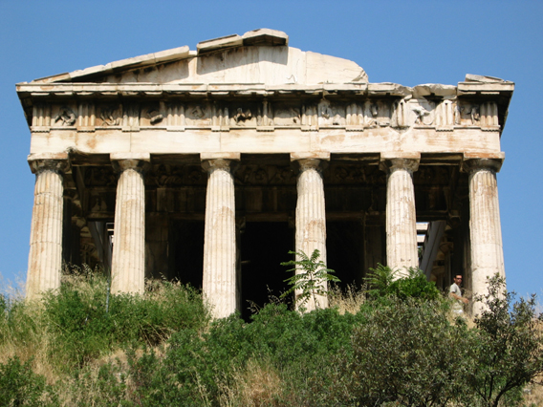
* vertical line at the mirror point
*/
public void mirrorTemple()

Gladiator the movie is publishing some posters and old Roman structures are going to be included.

They would like you to "Fix" This Temple picture.

Mirror part of the picture around a vertical point to "Fix the right side of the roof.

Grade:
print Mirror Temple method only.
Teacher check display of the picture with the Fix.

